W1-S2 PRACTICE
HTML ELEMENTS

 At the end of this practice, you should be able to…
- Manipulate Image, Tables, Lists, paragraphs, headings and hyperlinks

 How to work?
- Download the start code from the LMS
- Open the folder in VS Code

How to submit?
- Push your final code on your GitHub repository
- Then attach the GitHub path to the MS Team assignment and turn it in

 Are you lost?
You can read the following documentation to be ready for this practice:
- WC3 School - Links
- WC3 School -Tables
- WC3 School – Bloc and inline elements
- WC3 School -Tables

 No AI during this work!

- No AI during this practice so you can learn to solve problems by searching on internet.

EXERCISE 1 - A Blog Post
For this exercise, your need to create a simple blog post with the following structure:

- A <h1> for the title of the blog post (e.g., "My First Blog Post")
- Two paragraphs of text using the <p> tag, discussing any topic of your choice
- A hyperlink to an external website (e.g., link to a Wikipedia article related to your blog topic)
- A <h2> tag for a subheading (e.g., "Conclusion")
- A final paragraph summarizing your blog post.
  - You should also create a hyperlink to a mail (e.g., "any question, please contact me")

You can find bellow an example of post (just an example):


Output:
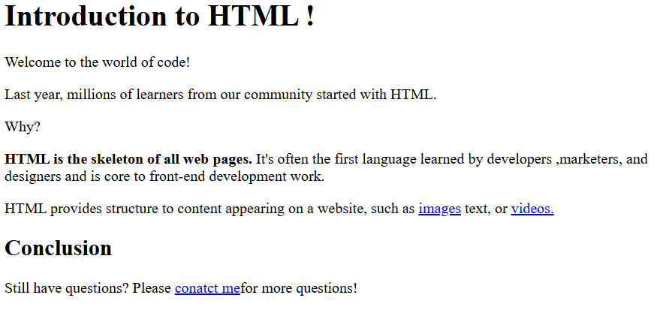

EXERCISE 2 – Relative paths
Here is a website folder structure.


YOU JOB: Fill the table with the missing hyperlinks, so that we can create a link from the source page to the destination page.

SOURCE PAGE | DESTINATION PAGE | HYPERLINK
action.html | cinema.html | <a href="../cinema.html">
home.html | songs.html | <a href="./music/songs.html">
help.html | action.html | <a href="./movies/action_movies/action.html">
cinema.html | help.html | <a href="../help.html">
action.html | home.html | <a href="../../home.html">
cinema.html | action.html | <a href="./action_movies/action.html">
songs.html | action.html | <a href="../movies/action_movies/action.html">
action.html | songs.html | <a href="../../music/songs.html">

EXERCISE 3 – A Small Website
For this exercise, you need to build a small website with 4 pages and a menu
- Home
- About us
- Our Services
- Contact
We should be able to navigate from any page to the other pages, using the menu

Each page of your website should contain:
- The menu
- A title
- An image
- A list of items
- A paragraph





Feel free to express your creativity!

- Home
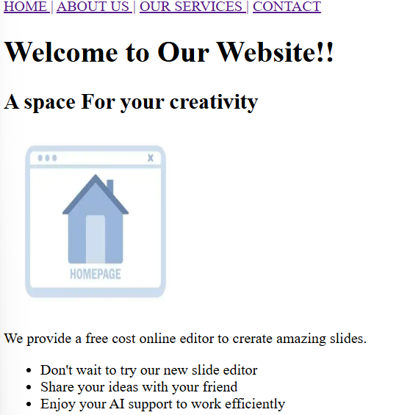

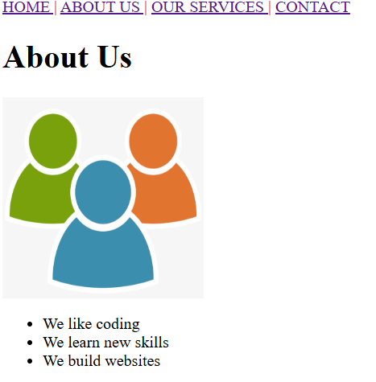
- About us

- Our Service
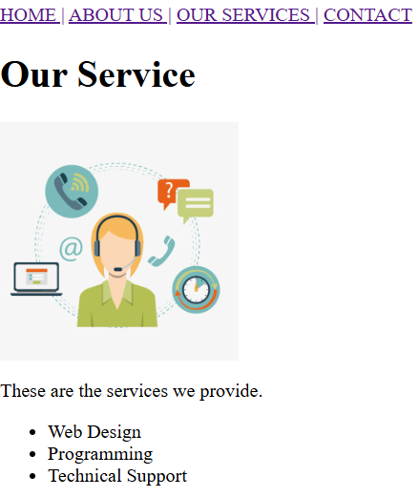

- Contact

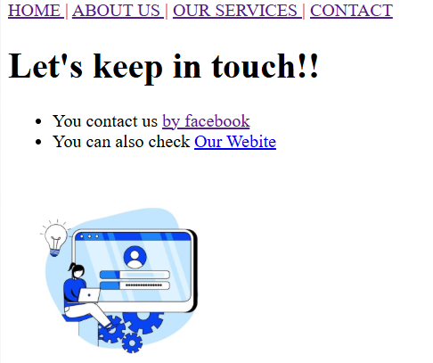

EXERCISE 4 – Product Information
For this exercise, you need to create tables
- Create a table to display a product catalog for an online store
- Use an <h2> tag to title the table (e.g., "Product Catalog").
- Create a table with 4 columns:
  - Product Name
  - Price
  - Quantity
  - In Stock

- Add 3 rows of product data with sample values (e.g., "T-shirt," "$10," "20," "Yes").
- Add a header row at the top of the table to describe each column.

Welcome to CADT Shop!

Product Name | Price | Quantity | In Stock
C# Book | $10 | 5 | YES
CADT Polo | $12 | 60 | YES
CADT mouse | $100 | 3 | NO

Output:

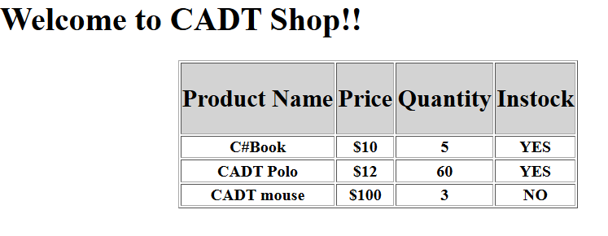

Are you lost?
- WC3 School -Tables

Bonus
- As a bonus: you add another column, containing a thumbnail (small image) of the products!
- As a bonus: you can try to style your table using the <style> tag inside the <header>

-Bonus:
